**Assignment ODE**

Gasification of a carbon particle: 2 C + O2 -> 2 CO

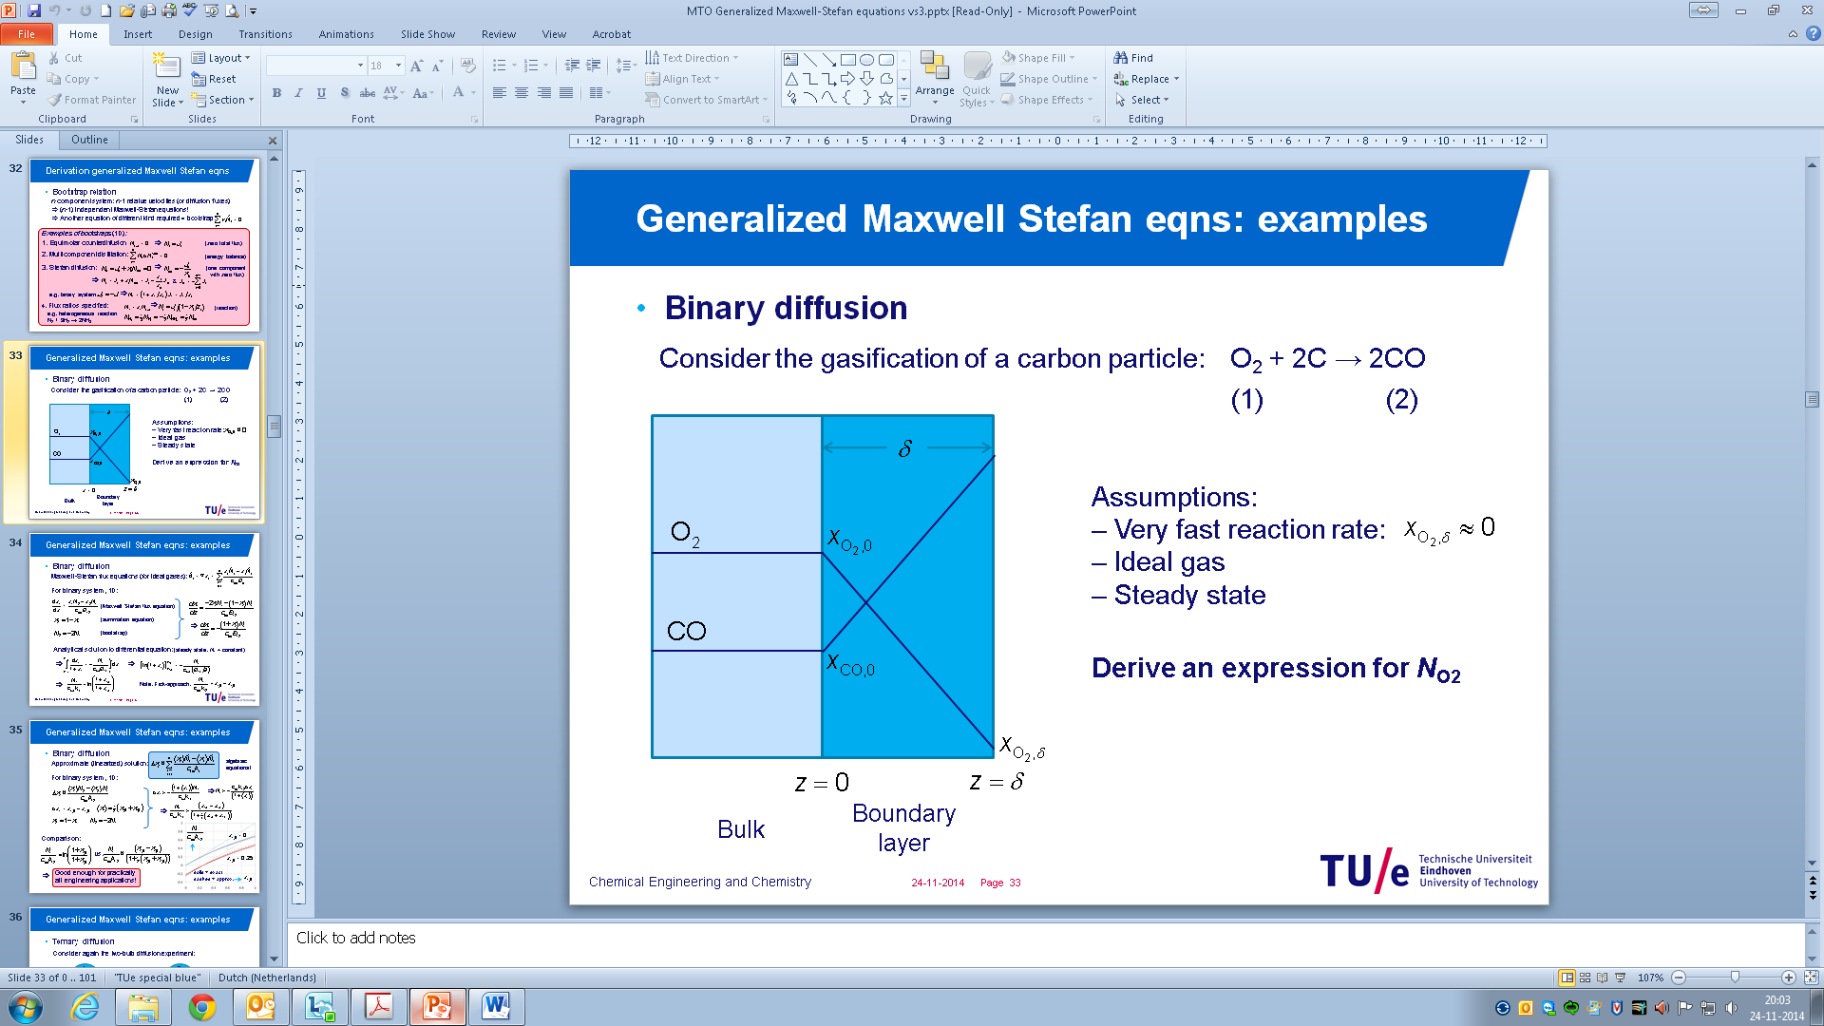

Assume: i) very fast reaction so that $x_{O_{2},δ}≈0$; ii) ideal gas; iii) steady state (decrease in particle size goes much slower than establishing of the concentration profiles;

Application of the Maxwell-Stefan equations for multi-component mass transfer yields (using 1 and 2 to denote O2 and CO respectively:

$$\frac{dx_{1}}{dz}=-\frac{\left(1+x_{1}\right)}{c_{tot}D_{12}}N_{1}$$

With the boundary conditions: $x_{1}\left(z=0\right)=x_{1,0}=0.2$ and $x_{1}\left(z=δ\right)=0$ (very fast reaction)

*P* = 1 atm; *T* = 873 K; *D12* = 1.6·10-3 m2/s, δ = 1.0·10-3 m

1. Solve this boundary value problem and calculate the O2 mole flux using the Maxwell-Stefan approach
2. Compare with the analytical solution by integrating the equation analytically
3. Compare the O2 mole flux with the Fickian approach and explain your result.